Crypto Lab 8

1. Write a Python script that takes two integers as input and calculates their GCD using the Euclidean algorithm.

Based on the result, determine whether these numbers are co-prime.

If they are co-prime, print a message indicating that they can be used in cryptographic key generation; otherwise, print a message that they are not suitable.

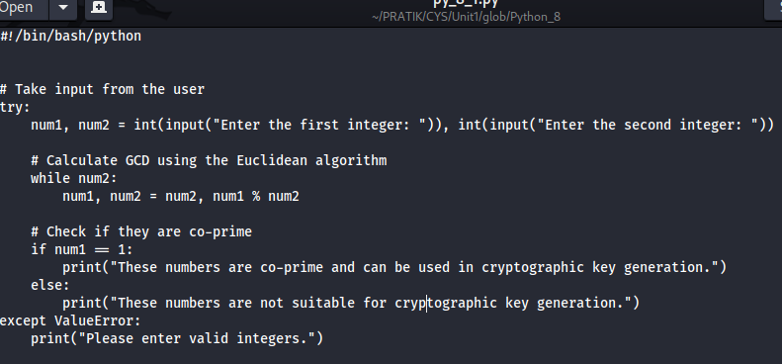

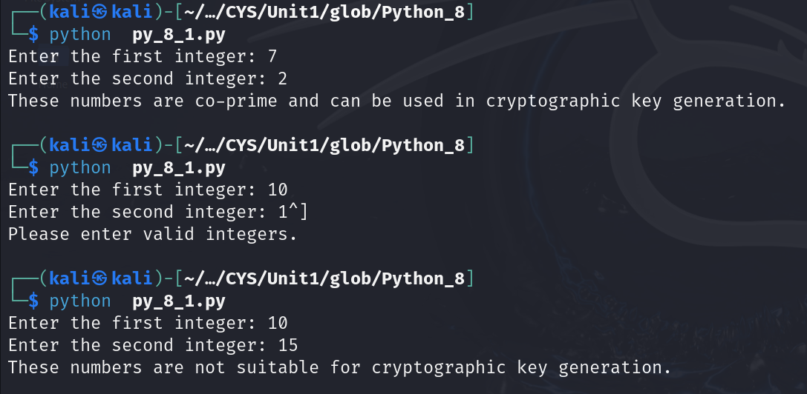

2. Write a python script to take two integer values (number (n) and modulo (m)) from the user and find the modular inverse using extended Euclidean algorithm.

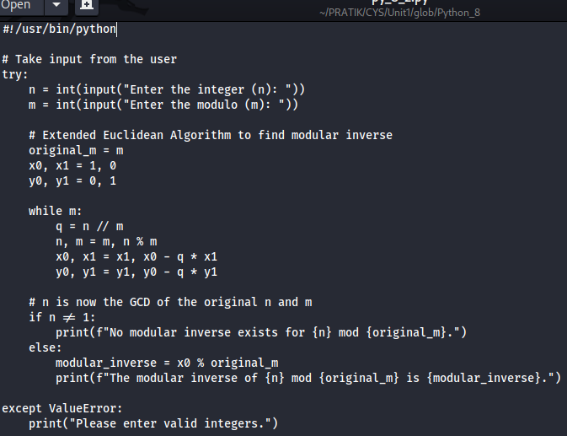

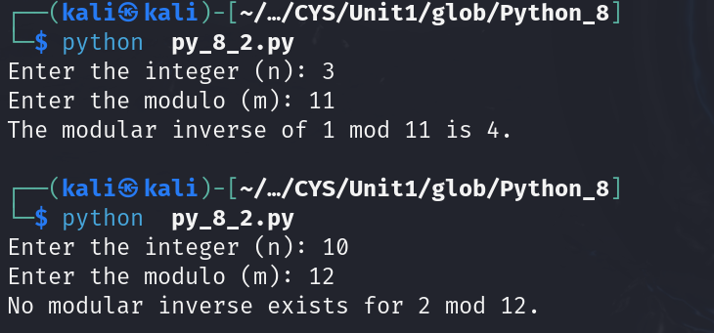

3. Write a Python script that generates a random binary number of length 100. The output should be a string of 100 binary digits (0s and 1s).

After generating the binary sequence, implement a function to check whether any subsequence of digits repeats itself within the sequence.



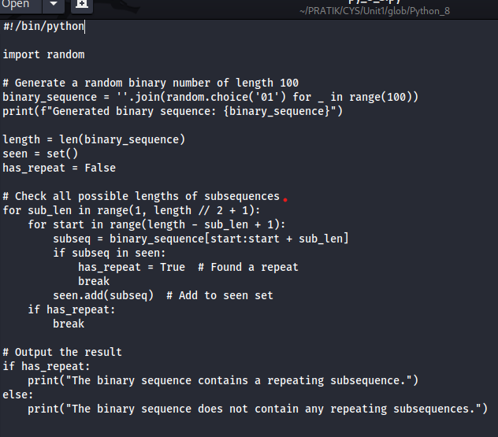

4. Write a Python script that performs the Golomb test to the numbers provided below.

101011001010

111111000000

The script should

- Perform and print the results of the three Golomb tests on the sequence.

- Print a message indicating whether the sequence passes the Golomb tests or not.

